1. Faced below error while applying the terraform apply.

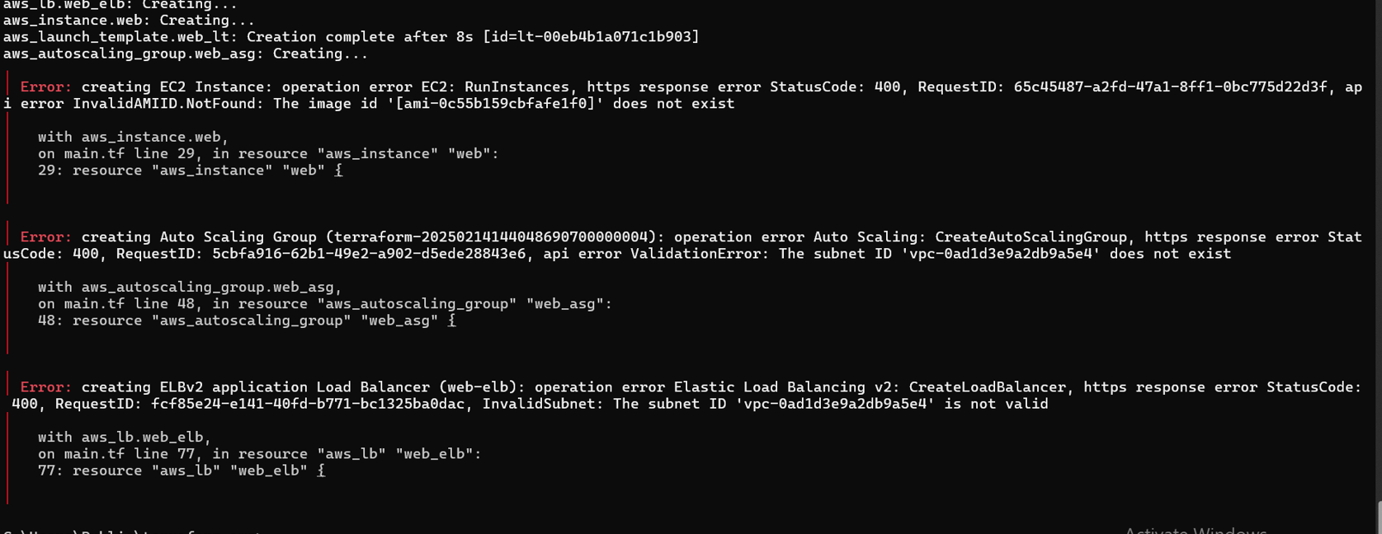

1. I faced script validation errors such as syntax errors and variable references errors which I have corrected easily but I forgot to take the screens shots.
2. I faced below issue while configuring https and it’s taking long time when creating and validating AWS ACM certificate using Terraform.

